EXP 5 K MANOJ KIRAAN
240701305

Campus Placement Management Application using Zia

Aim
To create a Campus Placement Management Application using Zoho Creator and use Zia to simplify placement-related data management and provide quick insights.
Procedure
- Create a new application in Zoho Creator named Campus Placement Management.
- Create forms for Student Details, Company Details, Job/Placement Details, and Applications.
- Add suitable fields such as student name, department, CGPA, company name, job role, eligibility, and application status.
- Create reports to view and manage student and placement information.
- Create workflows to update application status and manage placement activities.
- Use Zia to search, analyze, and obtain useful information from the application data using natural-language queries.
- Test the application by adding sample student and company records and checking the generated reports and Zia responses.
OUTPUT:
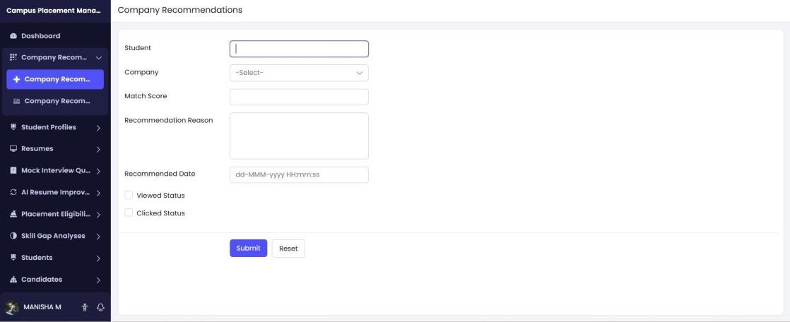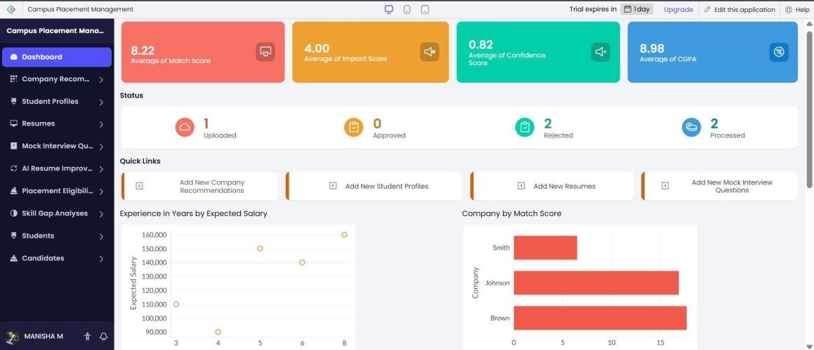
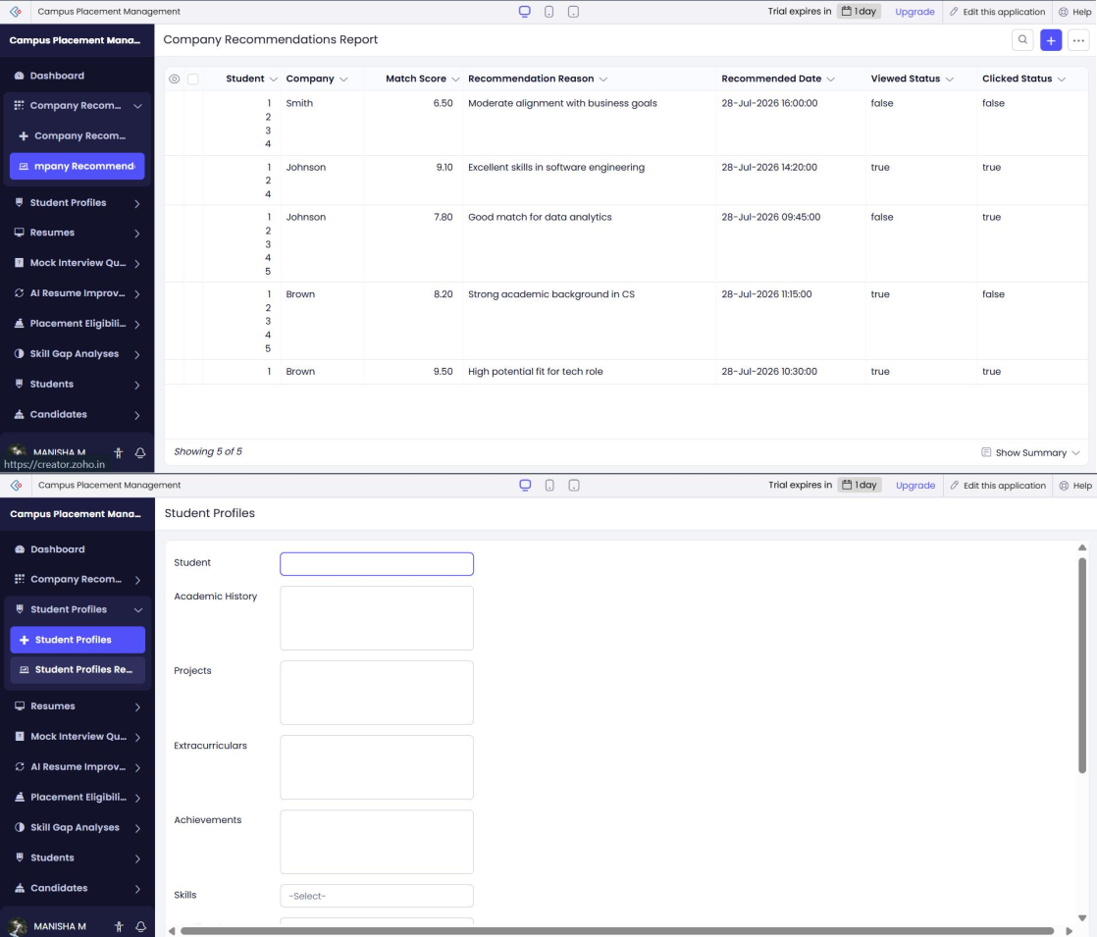
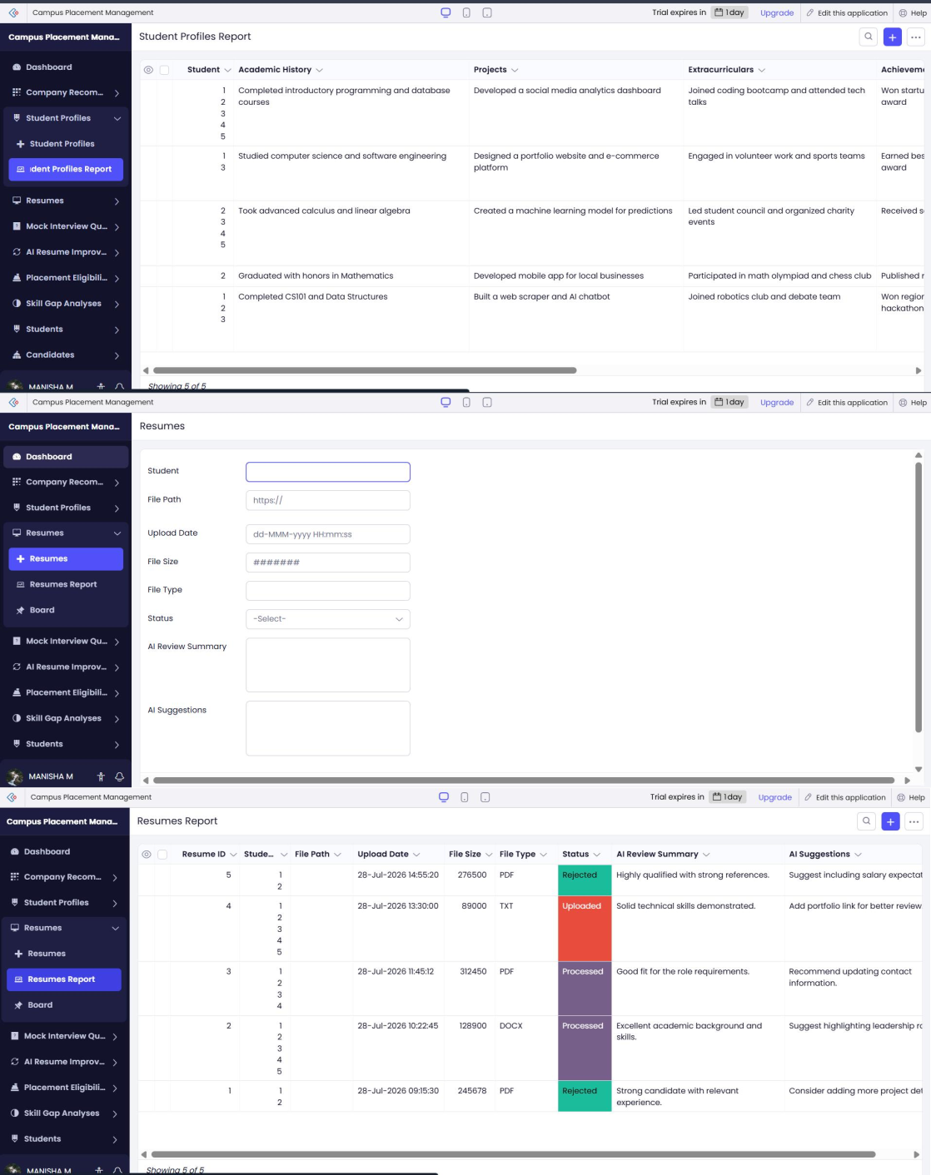
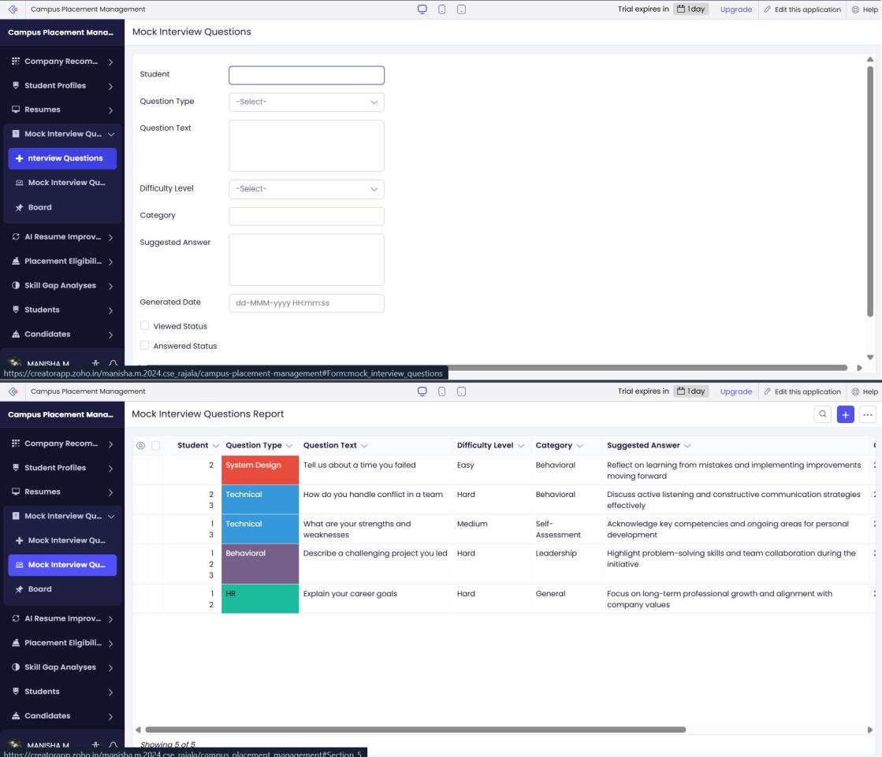
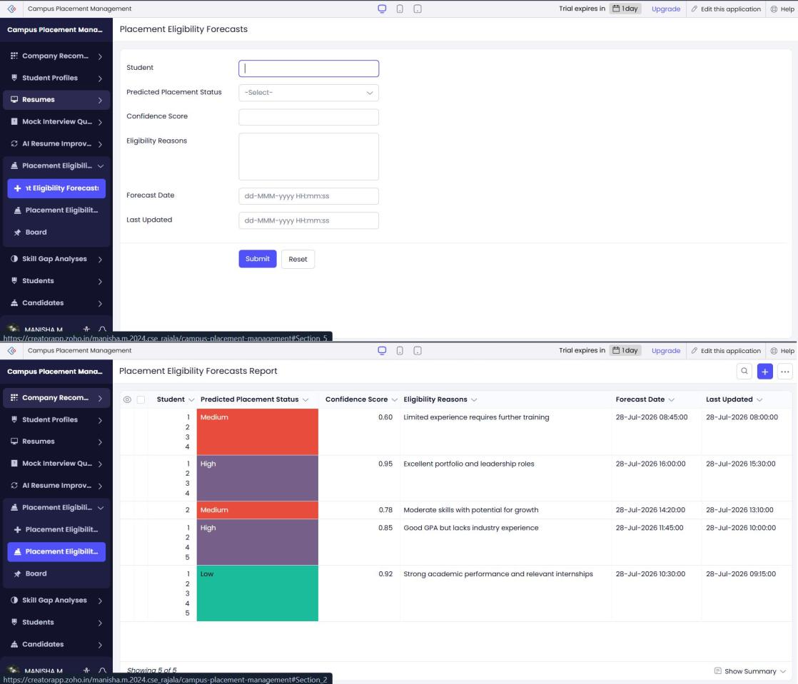
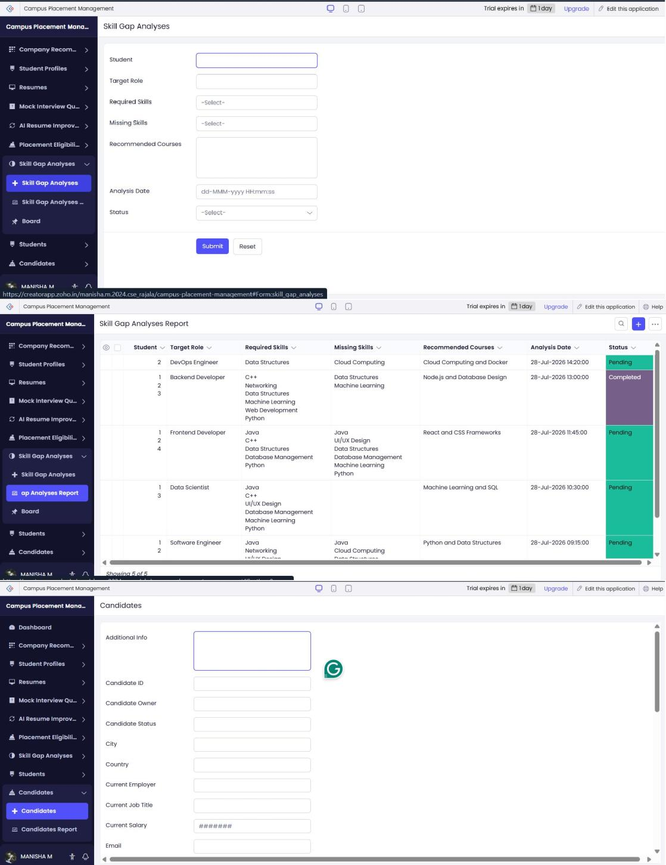
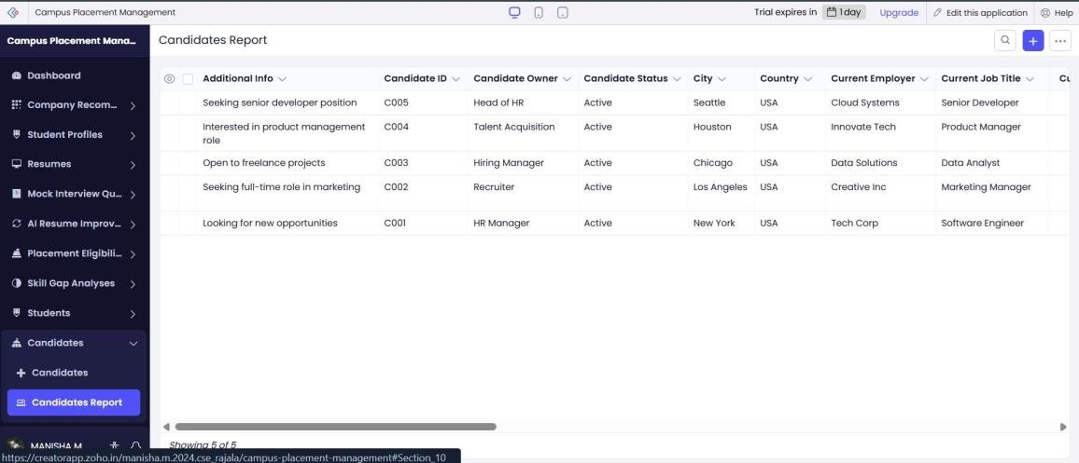

RESULT:
Thus, the Campus Placement Management Application was successfully created using Zoho Creator. Zia was used to obtain quick insights from placement data, making student and recruitment management easier and more efficient.

